Homework-01 – After mid
Embedded IOT Systems Fall2025
AI 5th

Question-1 ESP32 Webserver (webserver.cpp)
Part A: Short Questions
- What is the purpose of Webserver server (80); and what does port 80 represent?
Webserver server (80) creates a web server that checks for an incoming web request.
- It allows ESP32 to look like a mini website.
- Users can open ESP page in browser using IP address.
- Port80 is the default HTTP port. When we search IP on a browser, it automatically connects to port80.

- Explain the role of server. On ("/", handle Root); in this program.
This tells what to do when user opens the home page. HandleRoot is a function that runs when a page is requested.
For example:
Browser request https://ESP_IP/, it runs the handle root function.

- handleClient (? handleClient (); plloop (inside the loop () function? What will happen if it is removed?
It checks for new req uests and runs continuously in loop. If removes:
- ESP32 will not respond to browser requests.
- Web pages will not load or refresh.

- In handleRoot (), explain the statement:
server. send (200, "text/html", html).

The purpose of this line is to send webpage to browser.
200 is http status code, text/html is the content type of html page and html tells the actual code being sent.

5. What is the difference between displaying last measured sensor values and taking a fresh DHT reading inside handle Root ()?
In last measured sensor values:
It gives faster response.
More stable than Fresh values.
More suitable than Fresh values
It uses stored values.
Fresh values:
It gives slower response.
Not suitable as the last measured values.
Sensor takes new values.
Not stable may cause sensor errors.

Part B: Long Question
Describe the complete working of the ESP32 webserver-based temperature and humidity monitoring system.
Your answer should include:
- ESP32 Wi-Fi connection process and IP address assignment
- Web server initialization and request handling
- Button-based sensor reading and OLED update mechanism
- Dynamic HTML webpage generation
- Purpose of meta refresh in the webpage
- Common issues in ESP32 webserver projects and their solutions
1. ESP32 Wi-Fi Connection Process and IP Address Assignment
ESP32 connects to the network using WIFI. Begin (ssid, password). It operates in station mode, scans for the router, and performs authentication.
After successful connection, the router's DHCP server automatically assigns an IP address. This IP address reclaims using WiFi.localIP() and displayed on the serial monitor or OLED so users can access the web server. WiFi.status() monitors the connection state and can automatically reconnect if the connection drops.
2. Web Server Request Handling (Related to this code)
When a client browser requests the root page ("/"), the server executes the handler function. This handler:
Checks sensor data availability: First checks if valid sensor readings exist using isnan(lastTemp) || isnan(lastHum). If no valid data exists (NaN - Not a Number), it displays a message asking the user to press the button.
Generates appropriate content: Based on data availability, either shows "No valid data yet" message or displays actual temperature and humidity values.
Formats sensor values: Uses String (lastTemp, 1) to convert float values to strings with 1 decimal place precision for cleaner display.
Sends complete response: The entire HTML string is sent to the client with server. send (200, "text/html", html) where 200 indicates successful HTTP response.

3. Button-Based Sensor Reading and OLED Update
Button Reading: Button is connected to a GPIO pin.
Sensor Reading: When button press is detected:
- Call dht. readTemperature () and dht. readHumidity ()
- Validate the data (range check and checksum)
- Store valid readings in global variables.
OLED Update:
- Clear screen with display. clearDisplay ()
- Format and write temperature and humidity values to display buffer.
- Update screen with display. display ()

4. Dynamic HTML Webpage Generation
HTML Structure: The code builds a complete HTML document with proper structure including DOCTYPE declaration, head section with meta tags, and body content.
Conditional Content Generation: The key feature is conditional rendering based on sensor data state:
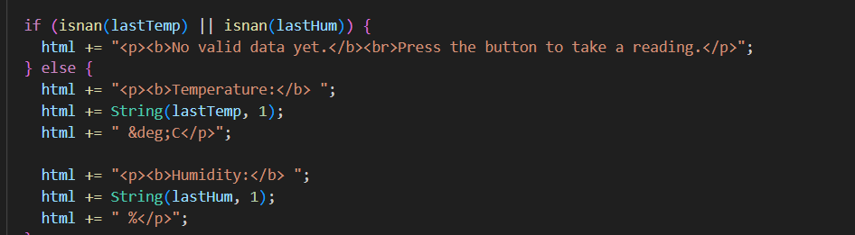
Data Embedding:
- Temperature and humidity values from global variables (lastTemp, lastHum) are dynamically inserted.
- String (lastTemp, 1) converts float to string with 1 decimal place.
- HTML entities like &deg; are used for degree symbol (°)

5. Purpose of Meta Refresh in the Webpage
Implementation in this code:
html += "<meta http-equiv='refresh' content='5'> “.
How it works: This meta tag in the head section tells the browser to automatically reload the entire page every 5 seconds. The content='5' specifies the refresh interval.
Specific Purpose in this System:
Automatic Data Updates: Since the button updates sensor readings and stores them in global variables (lastTemp, lastHum), the meta refresh ensures any new readings taken are visible in the browser without manual refresh.
Synchronization: If someone presses the physical button to update the OLED display, anyone viewing the webpage will see those updated values within 5 seconds automatically.
Simple Real-time Monitoring: Provides near real-time monitoring capability without complex JavaScript or WebSocket implementation. Perfect for simple IoT monitoring projects.

6. Common Issues and Solutions
WiFi Connection Failure:
- Check SSID/password (case-sensitive)
- ESP32 only supports 2.4GHz, not 5GHz.
- Place closer to router.
- Ensure stable power supply (3.3V)
Server Not Responding:
- Call server. handleClient () regularly in loop
- Avoid blocking delays.
- Use correct IP address.
- Check debug messages on serial monitor.
Sensor NaN Values:
- Allow 2 second delay between DHT readings.
- Verify sensor power supply.
- Add error handling to skip invalid readings.
Memory Crashes:
- Avoid large string concatenations.
- Keep HTML page size minimal.
- Use F () macro to store strings in flash memory.
OLED Not Working:
- Verify I2C address (usually 0x3C)
- Check SDA/SCL connections.
- Ensure proper display initialization.
Slow Loading:
- Minimize HTML
- Remove blocking operations from handlers.
- Consider AsyncWebServer library.

Question-2 Blynk Cloud Interfacing (blynk.cpp)
Part-A: Short Questions
- What is the role of Blynk Template ID in an ESP32 IoT project? Why must it match the cloud template?
- Blynk Template ID in ESP32 connect the ESP to specific blynk cloud template.
- It also tells cloud about which device is connecting and which widgets and streams to use.
- Blynk cloud template only uses the data of that device that is registered under the template. If it does not connect the device fails to connect.

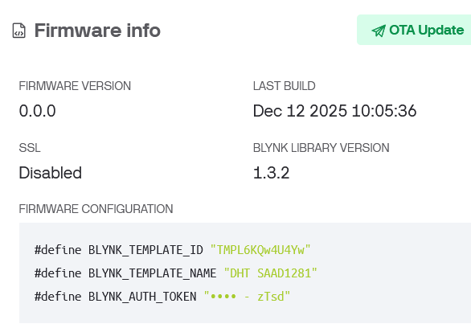

- Differentiate between Blynk Template ID and Blynk Auth Token.
- Blynk template id is used to identify the project template. It Is same for all devices of the project. It links firmware to template.
- Blynk Auth Token is used to authenticate the device. It is used for device security, and it also allows cloud access.

- Why does using DHT22 code with a DHT11 sensor produce incorrect readings? Mention one key difference between the two sensors.
- Using DHT22 code with a DHT11 sensor produces incorrect readings. It gives wrong temperature and humidity values.
- The key difference is that each sensor requires correct library configuration.

- What are Virtual Pins in Blynk? Why are they preferred over physical GPIO pins for cloud communication?
Virtual pins in ESP32 do not connect to real hardware pins. It is only used to send and receive data between ESP32 and blynk cloud.
They are preferred over physical GPIOs because of:
- No hardware
- Safe for cloud data.
- Multiple widget

For example:
Blynk.virtualWrite(V0, temperature).
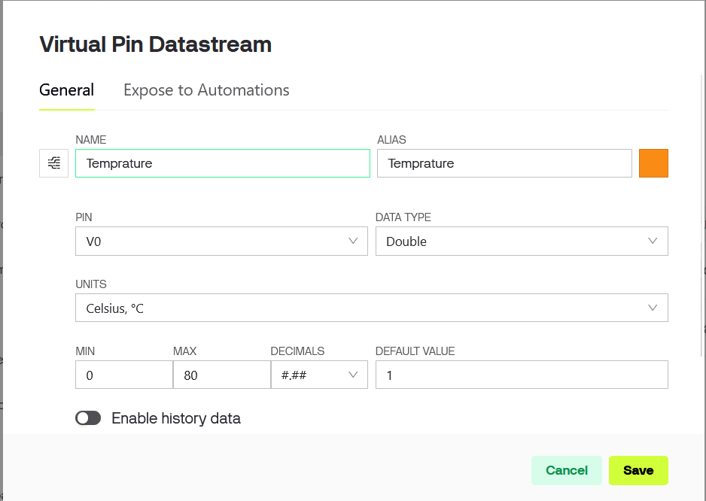

- What is the purpose of using BlynkTimer instead of delay () in ESP32 IoT applications?
The purpose of using BlynkTimer instead of delay () is it is non-blocking, does not block connection and keep connection alive while delay () blocks ESP and freeze WIFI and Blynk. Using delay () may cause blynk disconnection.

Part-B: Long Question
Explain the complete workflow of interfacing ESP32 with Blynk Cloud to display temperature and humidity values.
Your answer should include:
- Creation of Blynk Template and Datastreams
- Role of Template ID, Template Name, and Auth Token
- Sensor configuration issues (DHT11 vs DHT22)
- Sending data using Blynk.virtualWrite()
- Common problems faced during configuration and their solutions.

1. Creation of Blynk Template and Datastreams
Blynk Template: A template is a reusable configuration blueprint for IoT devices. To create one:
- Log in to Blynk Console (blynk. cloud)
- Navigate to "Templates" section.
- Click "New Template"
- Provide Template Name (e.g., "ESP32 DHT Monitor")
- Select Hardware as "ESP32"
- Choose Connection Type as "WiFi"
Creating DataStream: Datastreams are virtual channels that carry data between hardware and Blynk Cloud.
For temperature and humidity monitoring, create two DataStream’s:
Temperature DataStream (V0):
- Name: Temperature
- Virtual Pin: V0
- Data Type: Double
- Units: °C
- Min Value: -40
- Max Value: 80
- Decimals: 1
Humidity DataStream (V1):
- Name: Humidity
- Virtual Pin: V1
- Data Type: Double
- Units: %
- Min Value: 0
- Max Value: 100
- Decimals: 1
Mobile Dashboard: Similarly configure the mobile app dashboard with widgets linked to the same datastreams for remote monitoring.

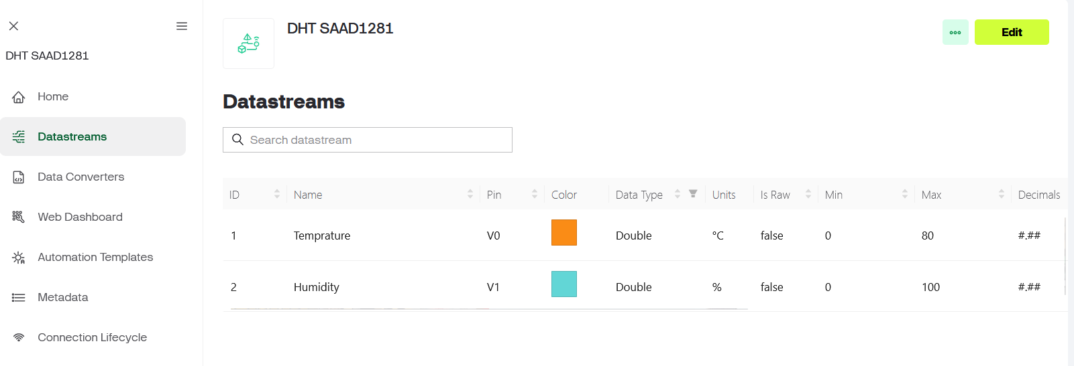

Template ID (TMPL_ID): A unique identifier automatically generated by Blynk when you create a template. Format: TMPLXXXXXX
Role:
- Links your device to the correct template configuration.
- Ensures device uses proper datastream definitions.
- Required for device authentication
- Must be included in firmware code.
Template Name (TMPL_NAME): The human-readable name assigned to your template (e.g., "DHTSAAD1281 ")
Role:
- Helps identify devices in Blynk Console
- Used for device organization and management.
- Appears in device lists and logs.
- Make debugging easier.
Auth Token (BLYNK_AUTH_TOKEN): A unique 32-character authentication key generated for each device.
Role:
- Security: Authenticates the specific device with Blynk Cloud
- Device Identity: Each device has unique token preventing unauthorized access.
- Data Routing: Ensures data from device goes to correct project/account.
- Access Control: Acts as password for device-cloud communication.

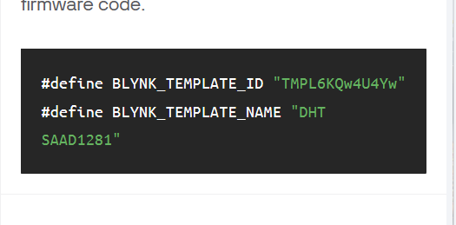

3. Sensor Configuration Issues (DHT11 vs DHT22)
DHT11:
- Range: 0-50°C, 20-80% humidity
- Resolution: Integer (1°C, 1%)
- Reading: Every 1 second
DHT22:
- Range: -40 to 80°C, 0-100% humidity
- Resolution: Decimal (0.1°C, 0.1%)
- Reading: Every 2 seconds minimum
Common Issues:
Wrong Sensor Type:
#define DHTTYPE DHT22 // Must match actual sensor
DHT dht (DHTPIN, DHTTYPE).

4. Common Problems and Solutions
Problem 1: Device Offline
- Check Auth Token is correct.
- Verify WiFi credentials (case-sensitive)
- Ensure Template ID match’s console.
- ESP32 only supports 2.4GHz WiFi.
Problem 2: NaN Readings
- Match DHTTYPE with actual sensor.
- Add 4.7kΩ pull-up resistor.
- Use stable power supply.
- Wait 2 seconds between readings.
- Check wiring connections.
Problem 3: Dashboard Not Updating
- Verify virtual pin numbers match (V0, V1)
- Check datastreams are created properly.
- Link widgets to correct datastreams.
- Do not exceed rate limits.
Problem 4: Compilation Errors
- Install libraries: Blynk, DHT sensor, Adafruit Unified Sensor
- Define Template ID/Name/Token before #include.
- Update ESP32 board definitions.

